
CO 2 ASSESSMENT TOOL 2 DESIGN ANALYSIS REPORT- SOFTWARE ENGINEERING
Medication Adherence Tracker for Elderly Patients
with Caregiver Alerts
NAME: Alima Banu R-192471044

Table of Contents

Section | Page
1. Introduction and System Objectives | 3
2. System Requirements Analysis | 3
2.1 Functional Requirements | 3
2.2 Non-Functional Requirements | 4
2.3 Key Quality Attributes Influencing the Architecture | 5
3. Selection of Suitable Software Architecture | 5
3.1 Selected Architectural Style | 5
3.1 Selected Architectural Style | 5
4. Software Architecture Diagram | 6
5. Components and Their Interactions | 7
5.1 Component Responsibilities | 7
5.2 Communication Mechanisms | 8
5.3 Representative Workflow: Missed-Dose Detection and Escalation | 9
6.1 Scalability | 9
6.2 Security | 10
6.3 Performance | 10
6.4 Reliability | 10
6.5 Maintainability | 10
6.6 Availability | 10
7. Justification of Architectural Decisions | 10
7.1 Rationale Summary | 10
7.2 Trade-offs Considered | 11
7.3 Support for Future Enhancements and Long-Term Maintainability | 11
8. Conclusion | 11

1. Introduction and System Objectives
Elderly patients managing chronic conditions frequently take multiple medications on overlapping schedules, and missed or incorrect doses are a leading cause of preventable hospitalizations. The Medication Adherence Tracker is a software system designed to help elderly patients take the right medication at the right time, while giving family caregivers and clinicians visibility into adherence patterns and the ability to intervene quickly when a dose is missed or an anomaly is detected.
Primary objective: provide a reliable, easy-to-use reminder and tracking system for elderly patients that automatically notifies caregivers when doses are missed, delayed, or taken incorrectly, and supports care-team decision making through adherence history and reports.
Secondary objectives derived from the problem statement include:
- Reduce missed doses through timely, accessible reminders (visual, audio, and optionally physical dispenser cues).
- Give caregivers and family members near real-time visibility into a patient's adherence status without requiring the patient to actively report it.
- Escalate unresolved missed doses to the appropriate person (family caregiver, then clinician, then emergency contact) within a bounded time window.
- Maintain an auditable, longitudinal adherence history usable by clinicians for treatment decisions.
- Operate reliably for a user population that may have low technical literacy, limited dexterity, or cognitive impairment, and that depends on the system for safety-critical reminders.
2. System Requirements Analysis
2.1 Functional Requirements
The functional requirements define what the system must do to support patients, caregivers, and clinicians.
# | Functional Requirement | Primary Actor
FR1 | Register and manage patient profiles, including prescribed medications, dosages, and schedules. | Clinician / Admin
FR2 | Generate and deliver medication reminders to the patient via app notification, voice prompt, or connected smart dispenser. | System / Patient
FR3 | Allow the patient (or dispenser sensor) to confirm that a dose was taken, skipped, or taken late. | Patient / IoT Device
FR4 | Detect missed doses when no confirmation is received within a configurable grace period. | System
FR5 | Send real-time alerts to linked caregivers when a dose is missed or a critical adherence event occurs. | System / Caregiver
FR6 | Escalate unacknowledged critical alerts to a secondary caregiver or on-call clinician after a timeout. | System
FR7 | Allow caregivers to view adherence history, trends, and upcoming schedules for linked patients. | Caregiver / Clinician
FR8 | Allow clinicians to update prescriptions and schedules, which propagate to the patient app and dispenser. | Clinician
FR9 | Support linking/unlinking of caregivers to a patient with configurable permission levels. | Patient / Admin
FR10 | Generate adherence reports (daily, weekly, monthly) exportable for clinical review. | Clinician / Caregiver

2.2 Non-Functional Requirements
Because the system issues safety-related reminders and alerts for a vulnerable population, its non-functional requirements are as important as its functional behavior.
Category | Requirement
Availability | The reminder and alerting path must be available 24/7 with at least 99.9% uptime; degraded operation must still allow local reminders on the patient device if connectivity is lost.
Reliability | Missed-dose detection and caregiver alerting must be dependable and not silently fail; alert delivery should be confirmed or retried.
Performance | Dose-confirmation events and missed-dose alerts must be processed and dispatched within a few seconds under normal load.
Scalability | The system must scale from pilot deployments (hundreds of patients) to large-scale deployments (hundreds of thousands of patients and caregivers) without redesign.
Security & Privacy | Medication and health data is sensitive (PHI); the system must enforce authentication, role-based access control, encryption in transit and at rest, and compliance with health-data regulations (e.g., HIPAA/GDPR-equivalent).
Usability | The patient-facing interface must be accessible to elderly users: large text, simple navigation, high color contrast, and voice support.
Maintainability | Individual features (e.g., alerting rules, new device integrations) must be updatable independently without redeploying the entire system.
Interoperability | The system should integrate with pharmacy and electronic health record (EHR) systems using standard healthcare data protocols.
Auditability | All adherence events, alerts, and prescription changes must be logged immutably for clinical and regulatory audit.

2.3 Key Quality Attributes Influencing the Architecture
Five quality attributes most strongly shape the architectural decisions for this system:
- Reliability and Availability — because a missed alert can have real health consequences, the architecture must avoid single points of failure in the reminder/alert path.
- Scalability — the number of patients, caregivers, and connected devices can grow substantially, and different components (e.g., notification dispatch vs. reporting) scale at different rates.
- Security — health data sensitivity demands strong access control, encryption, and isolation between services handling different data categories.
- Maintainability — the system will evolve over time (new device types, new escalation rules, new regulatory requirements), so components should be independently deployable.
- Performance (real-time responsiveness) — missed-dose detection and alert dispatch are time-sensitive and benefit from asynchronous, event-driven processing rather than tightly coupled synchronous calls.
3. Selection of Suitable Software Architecture
3.1 Selected Architectural Style
Selected style: a Hybrid Architecture combining Microservices (for independently deployable business capabilities) with an Event-Driven backbone (for real-time adherence monitoring and alerting), fronted by an API Gateway that serves multiple client types (Client-Server pattern at the edge).
This hybrid approach was chosen over a single pure style because the problem statement has two distinct characteristics that are each best served by a different pattern: (1) clearly separable business capabilities — user management, scheduling, monitoring, alerting, caregiver linking, and reporting — which map naturally to independent microservices; and (2) a time-critical, asynchronous notification workflow (dose taken → possibly missed → alert → escalation) which is naturally expressed as a stream of events rather than a chain of synchronous request/response calls.

3.2 Justification
- Independent scaling: notification dispatch and adherence monitoring may need to scale independently of, say, the reporting service, which microservices allow and a monolith does not.
- Fault isolation: a failure or slowdown in the reporting/analytics service must not prevent a missed-dose alert from being delivered; separating these into independent services with an event bus between them contains failures.
- Real-time responsiveness without tight coupling: the event-driven backbone lets the Adherence Monitoring Service publish a DoseMissed event that the Alert & Notification Service consumes immediately, without either service needing to know about the other's internal implementation or being blocked waiting on a synchronous call.
- Independent evolution and maintainability: new capabilities (e.g., a new IoT dispenser integration, or a new escalation channel) can subscribe to existing events or be added as a new service, satisfying the requirement that features be updatable independently.
- Multiple heterogeneous clients: the patient app, caregiver app, clinician portal, and IoT devices have very different needs (offline tolerance, low-bandwidth, accessibility); an API Gateway in front of the microservices provides a single, consistent entry point and shields clients from internal service topology.
A pure layered monolith was considered but rejected because it would couple the deployment and scaling of the alerting logic to unrelated features such as reporting, and would make it harder to isolate a failure in one module from affecting the whole system. A pure Serverless (Function-as-a-Service) approach was also considered for the alerting workflow, but was set aside as the primary style because several services (e.g., scheduling, user management) benefit from persistent stateful processes and predictable low-latency behavior; serverless functions remain a reasonable implementation choice within individual services, particularly for spiky, event-triggered workloads such as notification dispatch.
4. Software Architecture Diagram
The diagram below shows the major layers of the system: client applications, the API Gateway, the microservices layer, the event bus that connects services asynchronously, the per-service data stores, and the external systems the platform integrates with.
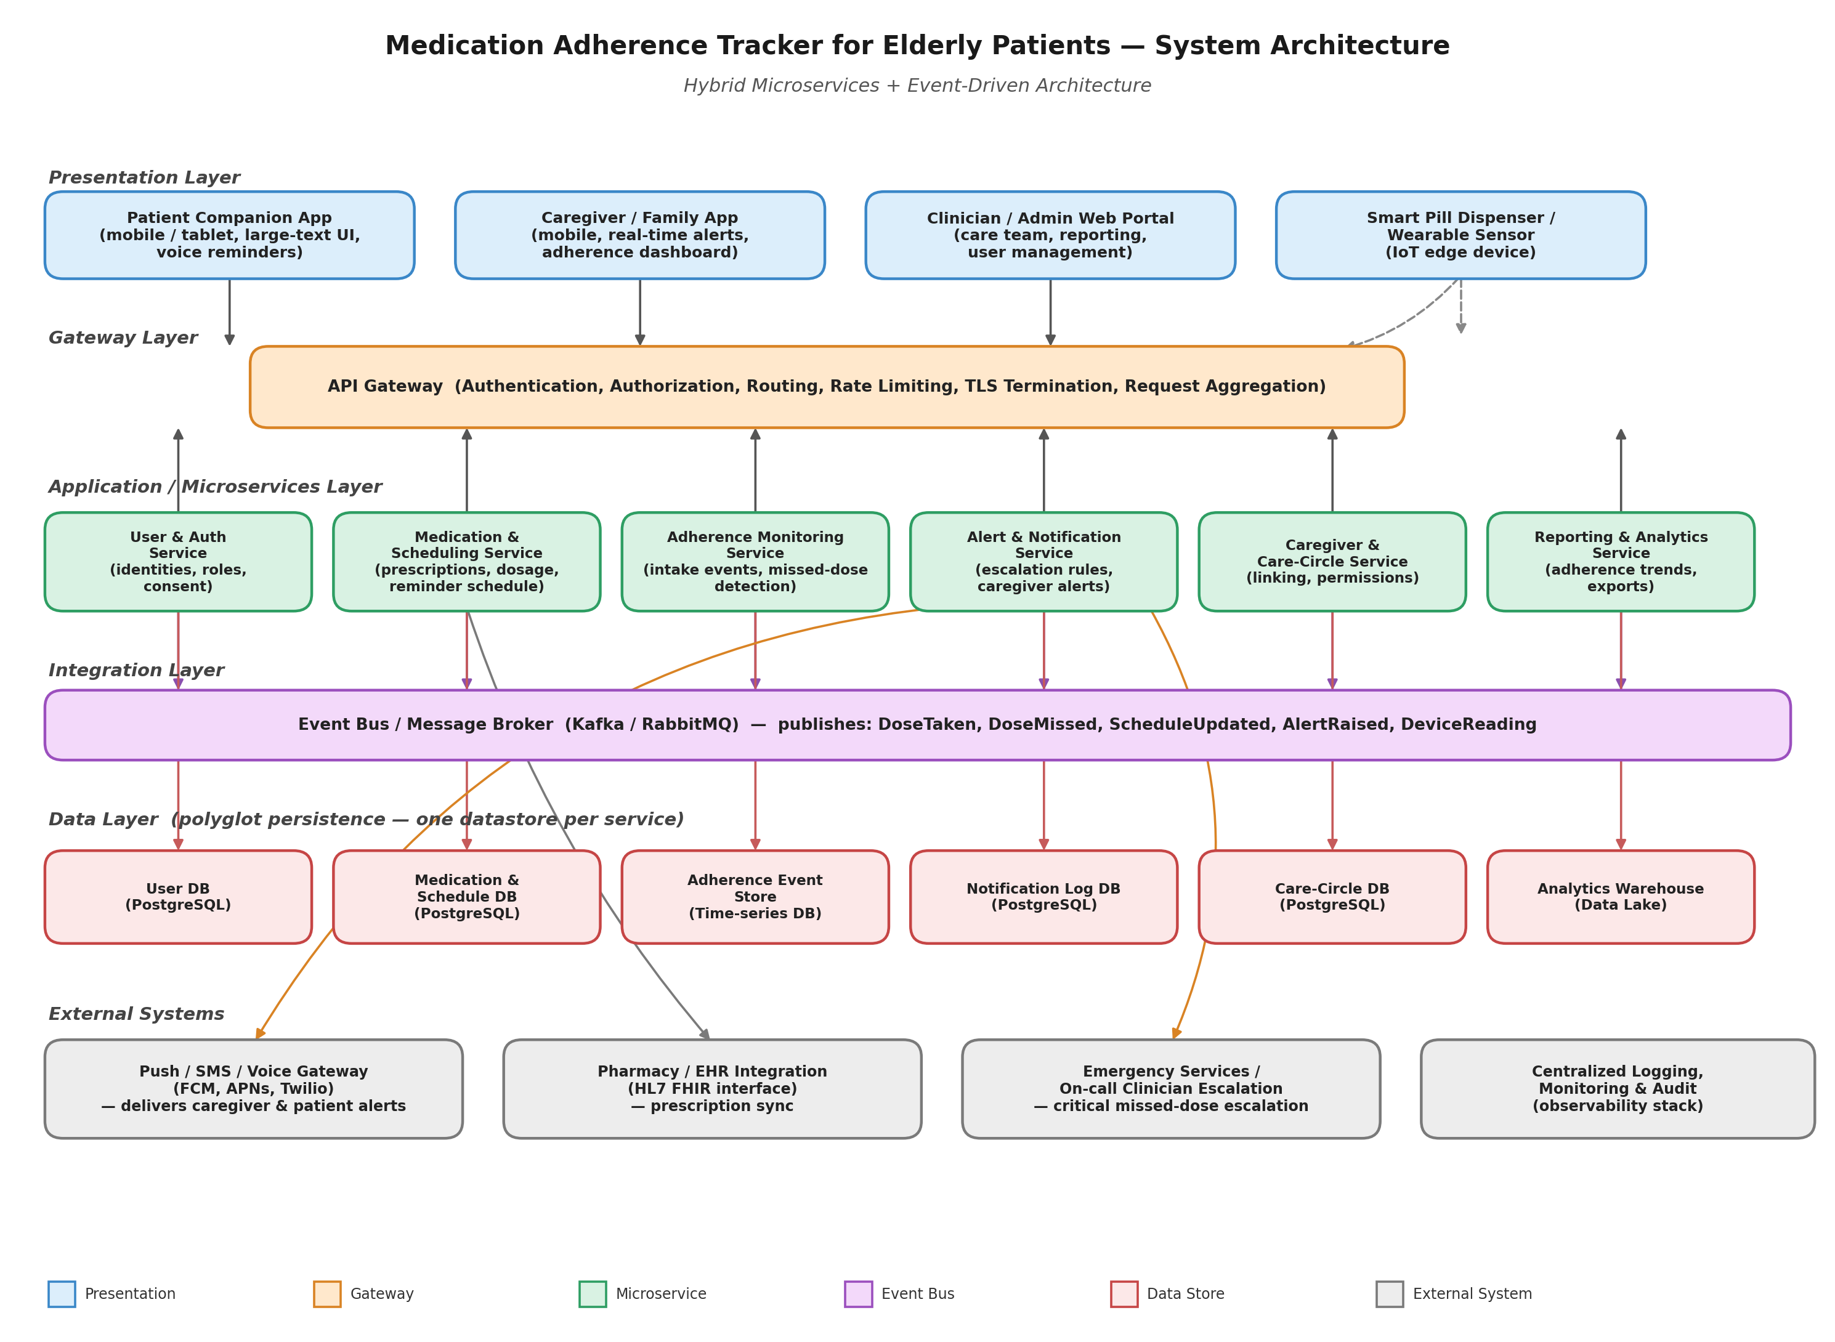
Figure 1. High-level architecture of the Medication Adherence Tracker, illustrating the Presentation, Gateway, Microservices, Integration (event bus), Data, and External Systems layers.
5. Components and Their Interactions
5.1 Component Responsibilities
Component | Responsibility
Patient Companion App | Displays reminders in an accessible format, captures dose confirmation, works offline-first and syncs when connectivity resumes.
Caregiver / Family App | Receives real-time alerts, displays adherence dashboard for linked patients, allows escalation acknowledgment.
Clinician / Admin Web Portal | Manages patients, prescriptions, schedules, and caregiver linkages; reviews adherence reports.
Smart Pill Dispenser / Wearable Sensor | Optional IoT edge device that can physically dispense or sense medication removal and report readings.
API Gateway | Single entry point for all clients; handles authentication, authorization, routing to the correct microservice, rate limiting, and TLS termination.
User & Auth Service | Manages identities, credentials, roles (patient, caregiver, clinician, admin), and consent records.
Medication & Scheduling Service | Stores prescriptions, dosages, and reminder schedules; generates the next scheduled reminder time for each patient.
Adherence Monitoring Service | Consumes dose-confirmation and device-reading events, determines whether a dose was taken on time, and raises DoseMissed events when a grace period elapses without confirmation.
Alert & Notification Service | Applies escalation rules to adherence events and dispatches alerts to the correct caregiver, and further escalates if alerts are not acknowledged in time.
Caregiver & Care-Circle Service | Manages relationships and permission levels between patients and their caregivers/clinicians.
Reporting & Analytics Service | Aggregates historical adherence data into trends and exportable reports for clinicians and caregivers.
Event Bus / Message Broker | Decouples services by carrying domain events (DoseTaken, DoseMissed, ScheduleUpdated, AlertRaised, DeviceReading) between publishers and subscribers.
Per-service Data Stores | Polyglot persistence: each microservice owns its own database, chosen to fit its access pattern (e.g., a time-series store for adherence events).
Push/SMS/Voice Gateway | External provider (e.g., FCM, APNs, Twilio) used to deliver notifications to caregiver and patient devices.
Pharmacy / EHR Integration | External interface (e.g., HL7 FHIR) used to synchronize prescriptions with pharmacy and health-record systems.
Monitoring & Audit | Centralized logging, metrics, and immutable audit trail across all services.

5.2 Communication Mechanisms
- Client to Gateway: synchronous HTTPS/REST (or GraphQL) requests, authenticated with OAuth2/JWT tokens issued by the User & Auth Service.
- Gateway to Microservices: synchronous REST/gRPC calls for request/response interactions (e.g., fetching a schedule, updating a prescription).
- Service to Service (state changes): asynchronous publish/subscribe messaging through the event bus, so producers and consumers are decoupled and can be scaled or deployed independently.
- Device to Platform: lightweight, low-bandwidth protocol (e.g., MQTT over TLS) from the smart dispenser/wearable to the Gateway or a dedicated IoT ingestion endpoint, converted into DeviceReading events.
- Platform to External Systems: outbound integrations via provider SDKs/APIs (push/SMS gateway) and healthcare-standard interfaces (HL7 FHIR for EHR/pharmacy).
5.3 Representative Workflow: Missed-Dose Detection and Escalation
The following sequence illustrates how the components interact for the system's most safety-critical workflow.
- 1. The Medication & Scheduling Service determines it is time for a dose and triggers a reminder, delivered to the Patient Companion App (and dispenser, if connected) via the Gateway.
- 2. The patient confirms the dose (or the dispenser senses removal); the app publishes a DoseTaken event onto the event bus.
- 3. If no confirmation arrives within the configured grace period, the Adherence Monitoring Service publishes a DoseMissed event.
- 4. The Alert & Notification Service, subscribed to DoseMissed events, looks up the patient's care circle via the Caregiver & Care-Circle Service and sends an alert to the primary caregiver through the Push/SMS/Voice Gateway.
- 5. If the alert is not acknowledged within a set escalation window, the Alert & Notification Service automatically escalates to a secondary caregiver or on-call clinician, and for critical cases, to the Emergency Services / Clinician Escalation channel.
- 6. All events (reminder sent, dose taken/missed, alert raised, escalation triggered) are recorded for the Reporting & Analytics Service and the audit log.
6. Discussion of Quality Attributes
6.1 Scalability
Because each capability is a separate microservice, components with different load profiles can be scaled independently: for example, the Alert & Notification Service can be scaled up during peak reminder times (e.g., mornings) without over-provisioning the Reporting & Analytics Service. The event bus also buffers bursts of adherence events, smoothing load spikes so that a surge of dose confirmations does not overwhelm downstream consumers. As patient volume grows, new service instances can be added behind the Gateway with no change to client applications.
6.2 Security
All client traffic is authenticated and authorized centrally at the API Gateway, and role-based access control at the User & Auth Service ensures caregivers only see data for patients they are explicitly linked to. Data is encrypted in transit (TLS) and at rest, and separating data into per-service stores limits the blast radius of a compromise in any one service. The Monitoring & Audit component provides an immutable trail of who accessed or changed what, supporting compliance with health-data regulations.
6.3 Performance
The event-driven integration layer allows time-critical processing (dose confirmation, missed-dose detection, alert dispatch) to happen asynchronously and in near real time, without waiting on unrelated, potentially slower operations such as report generation. Synchronous paths (Gateway to microservices) are kept short and narrowly scoped to keep client-facing response times low, while long-running or bulk operations (analytics aggregation) are handled out of the critical path.
6.4 Reliability
The message broker provides durable, at-least-once delivery of events, so a temporary outage in the Alert & Notification Service does not lose a DoseMissed event — it is retried once the service recovers. Redundant instances of each microservice, combined with health checks and automatic failover at the Gateway, reduce the risk of a single instance failure disrupting the reminder or alerting path. The Patient Companion App is designed to queue reminders locally so brief connectivity loss does not stop the patient from receiving a reminder.

6.5 Maintainability
Each microservice has a single, well-bounded responsibility and its own data store, so teams can modify, test, and deploy one service (for example, adding a new escalation rule) without touching or redeploying the others. The event bus's published event schema acts as a stable contract between services, allowing internal implementation changes as long as the event contract is preserved.
6.6 Availability
Stateless services behind the Gateway can run multiple replicas across availability zones, and the event bus itself is typically deployed as a replicated cluster, avoiding single points of failure in the critical reminder-alert path. Graceful degradation is built in: if backend connectivity is lost, the Patient Companion App can still show locally cached reminders, and once connectivity is restored, queued adherence events are synchronized.
7. Justification of Architectural Decisions
7.1 Rationale Summary
The hybrid microservices plus event-driven architecture directly addresses the dominant quality attributes identified in Section 2.3: it isolates the safety-critical alerting workflow so it can be independently reliable and scalable, it enables asynchronous, low-latency processing of adherence events, and it keeps the system maintainable as new device integrations, escalation policies, and reporting needs are added over time.
7.2 Trade-offs Considered
Decision | Benefit Gained | Cost / Trade-off Accepted
Microservices instead of a monolith | Independent scaling, deployment, and fault isolation per capability. | Higher operational complexity: more services to deploy, monitor, and version; requires service discovery and distributed tracing.
Event-driven integration instead of synchronous chaining | Loose coupling and real-time responsiveness for the alerting workflow. | Eventual consistency between services; requires careful handling of event ordering, duplicate delivery, and monitoring for unconsumed events.
Polyglot persistence (one database per service) | Each service can choose the data model best suited to its access pattern (e.g., time-series for adherence events). | No cross-service joins or single global transaction; cross-service views (e.g., reports) must be built by aggregating events or via a reporting store.
Centralized API Gateway | Single point for authentication, consistent client experience, simplified client development. | Gateway must itself be made highly available, or it becomes a single point of failure for all client traffic.

7.3 Support for Future Enhancements and Long-Term Maintainability
- New device types (e.g., additional wearables or smart pillboxes) can be integrated by adding a new event producer that publishes DeviceReading events, with no change to the Adherence Monitoring or Alert services.
- New escalation channels (e.g., a smart-speaker voice alert, or integration with a national emergency-response system) can be added as new subscribers to existing alert events.
- New markets or regulatory regions can be supported by deploying additional instances of data-sensitive services within region-specific boundaries, since services are already independently deployable.
- The Reporting & Analytics Service can evolve toward predictive adherence risk-scoring (e.g., using historical patterns to flag patients at risk of non-adherence) by consuming the same event stream without modifying the operational services.
- Because each service is independently deployable and communicates through well-defined APIs and event contracts, the system supports continuous delivery: individual capabilities can be updated, tested, and released without a full-system redeployment, which is essential for a system that must remain highly available for a vulnerable user population.
8. Conclusion
The Medication Adherence Tracker's core challenge is reliably closing the loop between a scheduled dose and a timely human response when that dose is missed, for a user population where reliability and simplicity are safety-critical. A hybrid microservices and event-driven architecture, fronted by a single API Gateway, was selected because it isolates this critical path for independent scalability and reliability, supports the system's diverse client types, and keeps the system maintainable and extensible as new devices, escalation policies, and analytics capabilities are added over time. The trade-offs accepted — increased operational complexity and eventual consistency between services — are reasonable given the strong benefits in fault isolation, responsiveness, and long-term evolvability that the problem statement demands.

